

**CURRICULUM VITAE**

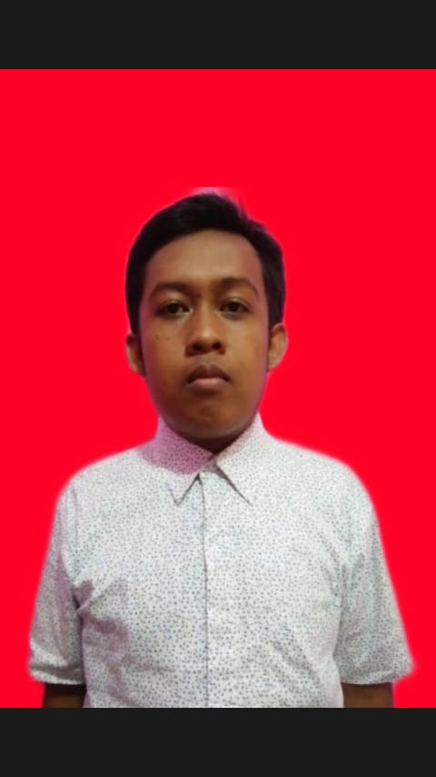

**Ahmad Rizki Husaini**

**SUMMARY**

I am a student of UIN Jakarta, my full name is Ahmad Rizki Husaini. This year I am 20 years old, in other words my productive age. I do not have any serious congenital disorders or illnesses and I am in good physical and mental health. I have an interest in technology and classification book, and have little interest in the world of information and technology, but I have basic skills in those fields, both in installing and running software. I also have basic skills language in only English Language, but soon I will learn Japanese language.

**ADDRESS**

**JLH.Dimun RT/RW :05/06 Kp. Sudamukti Cilodong**

**Depok-West Java**

**PROFILE**

Full Name : Ahmad Rizki Husaini

Place, Date of Birth : Depok, 16 Juli 2001

**PHONE NUMBER**

Height : 160 Cm

Weight : 72 Kg

**08811323272**

**085776507656**

Religions : Moslem

Status : College Student

**EMAIL**

Nationality : Indonesia

**rizkihusaini44@gmail.com**

**EDUCATION**

MI Darul Falah II (2007-2012)

**EXPERIENCES**

MTs An-Nizhomiyah (2012-2015)

MAN 1 Bogor (2015-2018)

UIN Syarif Hidayatullah University Jakarta (2019-up to present)

**Had an internship at the library of the Ministry of Education and Culture (2020)**

**KEMAMPUAN**

LEADERSHIP

ABLE TO RUN MS OFFICE (WORD AND POWERPOINT)

HAVE BASIC IN ENGLISH AND PRE-TO INTERMEDIATE

HAVE BASIC IN HTML AND CSS